Steps for Eclipse Project Setup

Prerequisite:

Download the following tools from the SVN from below URL Download jdk-jre, eclipse and tomcat
URL:
http://192.168.0.181:3690/svn/crestelmediation/projects/SM_REVAMP/tools/

- File > New > Others > Project from SVN

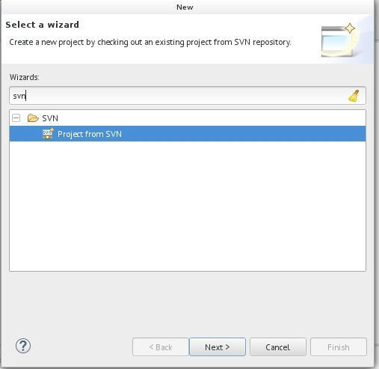

- Enter Project SVN URL and Credentials

URl: http://192.168.0.181:3690/svn/crestelmediation/projects/SM_REVAMP/ServerManager/trunk

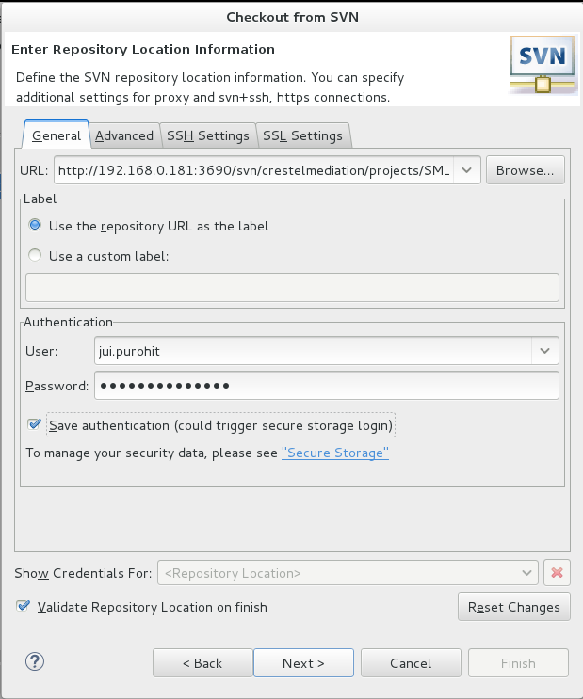

After adding details click Next

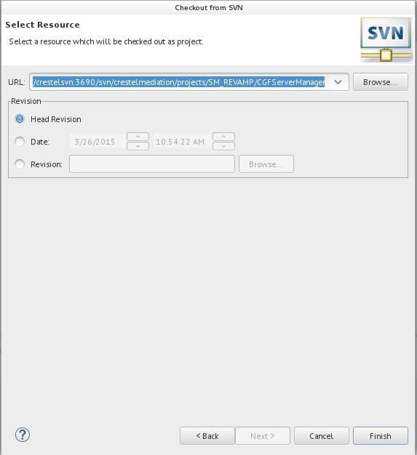
Click Finish
3. Checkout the Project
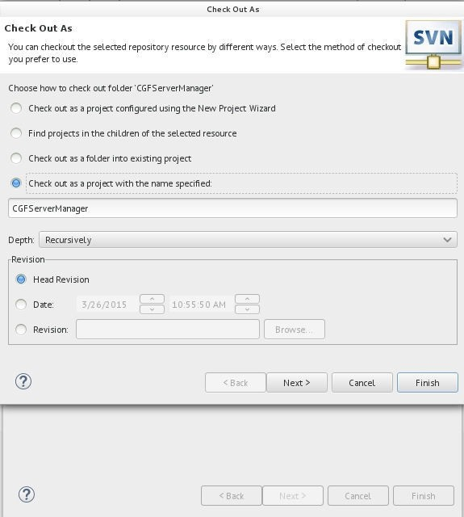

Click Next

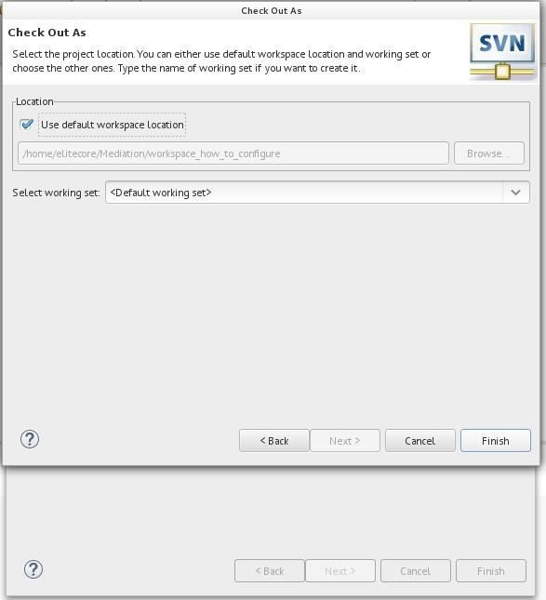
- Project will be added to workspace

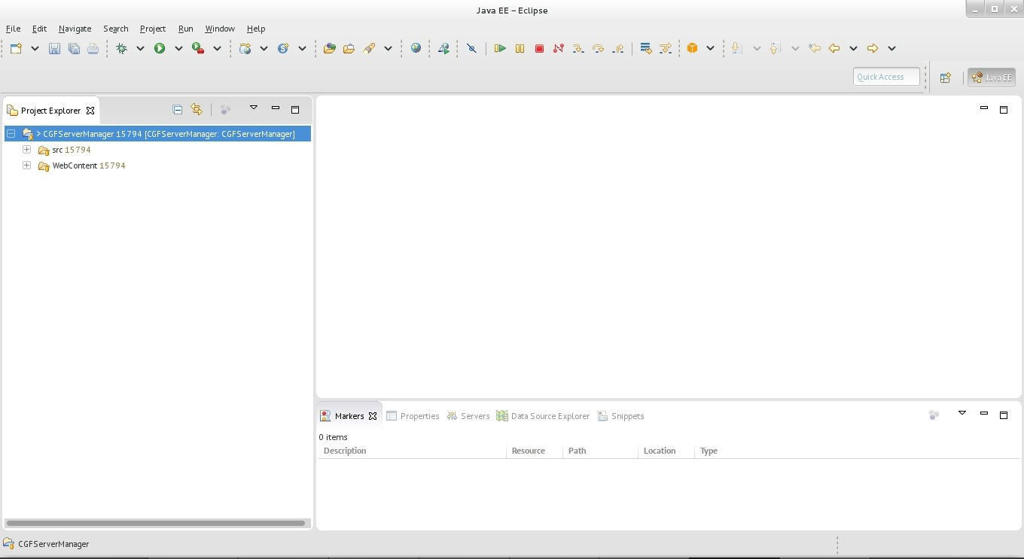
- Right click on Project > Properties > Project Facets > Click on Covert to Facet Form...

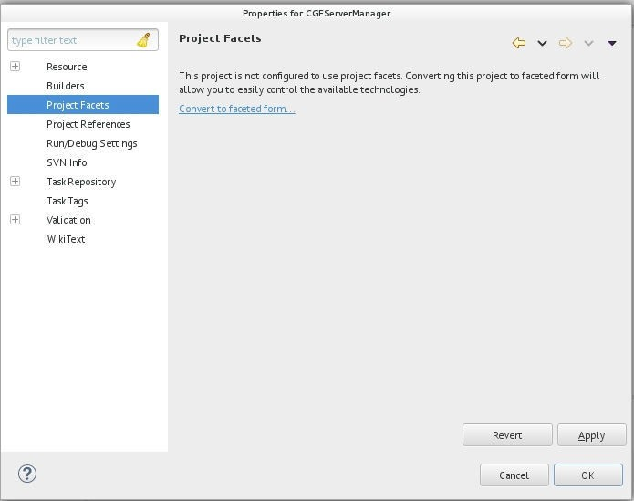
- Select the Dynamic Web Project and Version as 2.5 or 3.0
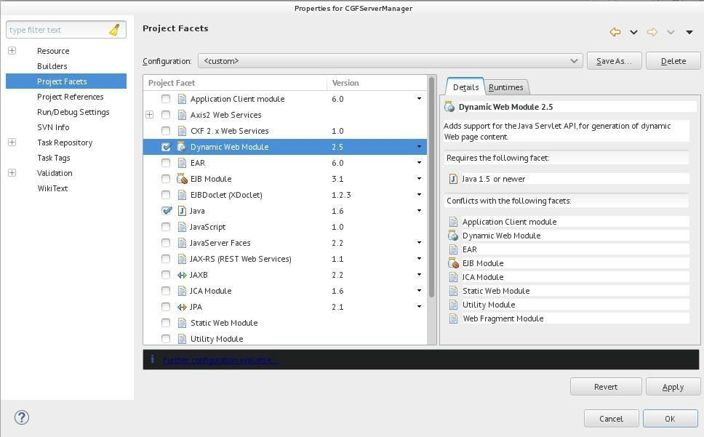
- Click on Runtime Tab
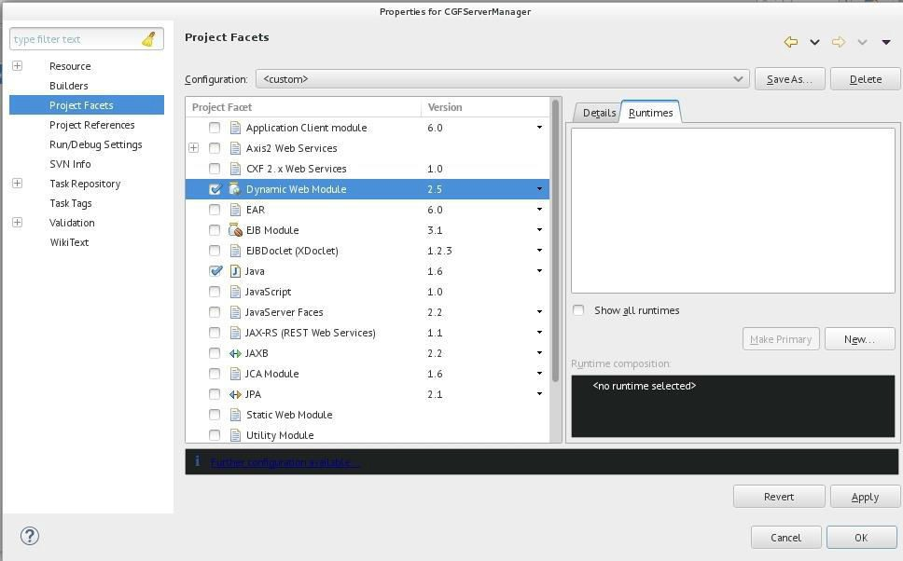
- Add Tomcat Server 7 By clicking New in Runtime Tab
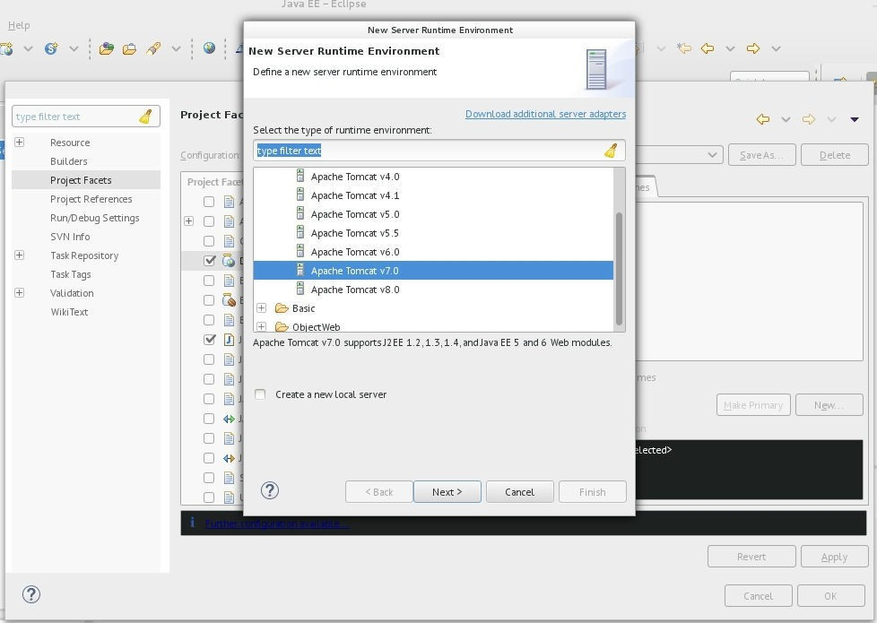
- Add Tomcat Path
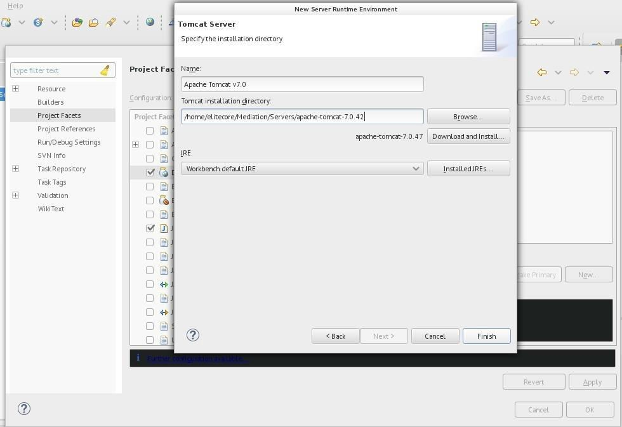
- Select checkbox of Tomcat Server in Runtime Tab

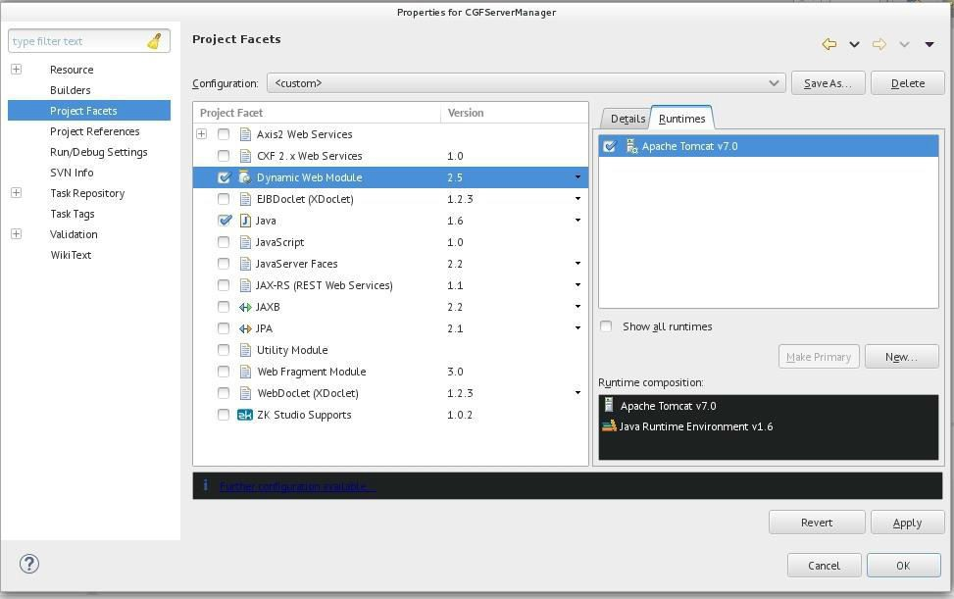

Click Apply and Then Click Ok.
- In Server Tab View- double click on the Tomcat 7 Server and change the properties

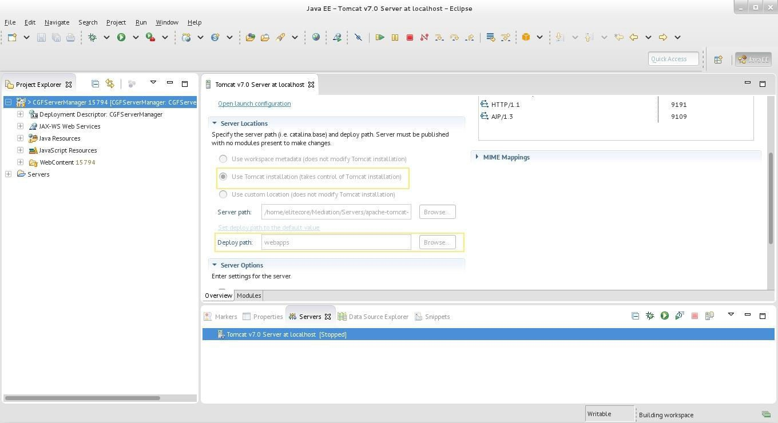
- Change the deployment assembly properties

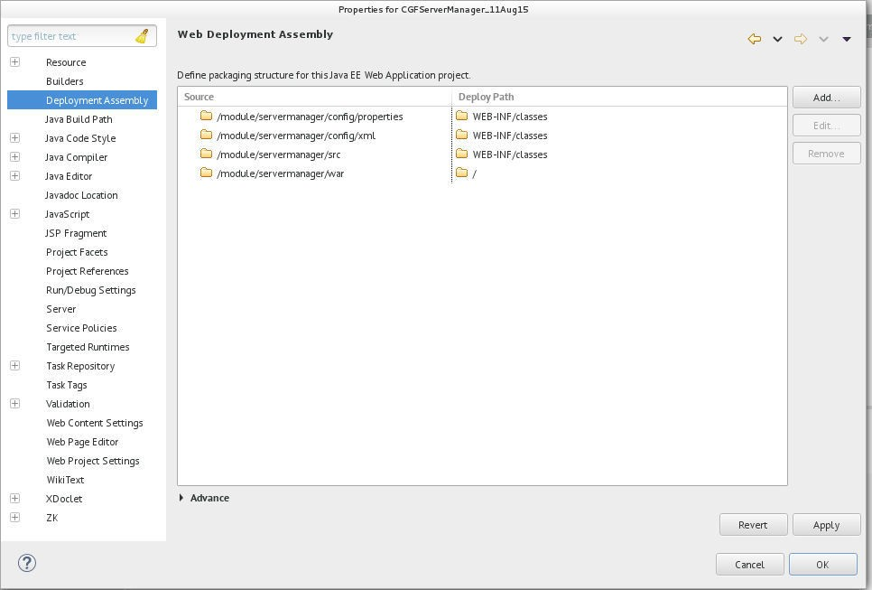
- Change the source folder path

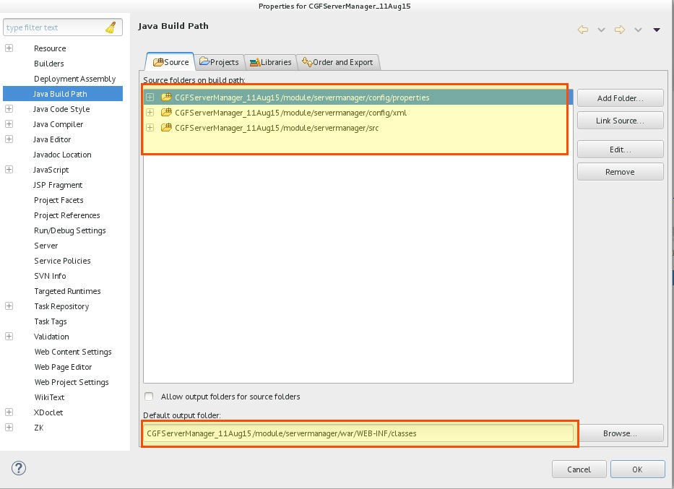
- Add lib to Java Build Path & Check for JRE Library is bounded properly.

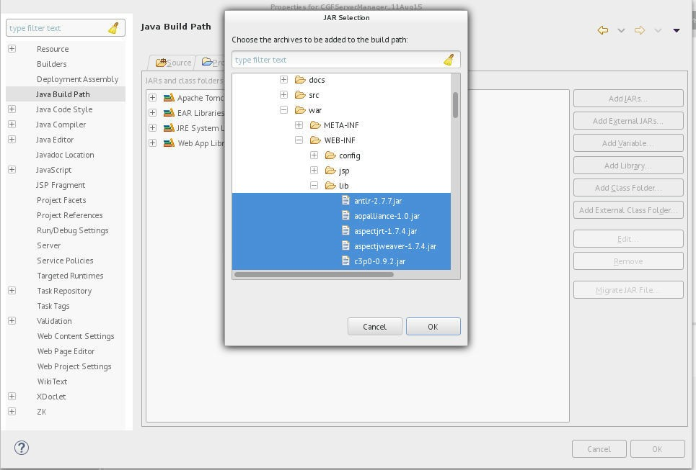
- Add Context Entry in Tomcat config > server.xml

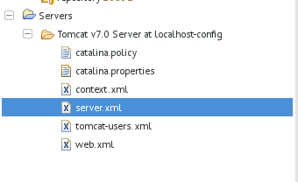

Add below context entry under host tag:
<Context docBase="PATH_TO_WAR_FOLDER_IN_MODULE" path="/sm" reloadable="true"/> Example:
<Context docBase="/home/elitecore/Mediation/workspace_how_to_configure_1/CGFServerManager_1/module/servermanager/w ar" path="/sm" reloadable="true"/>

Finally Project is configured

- Now make suitable changes according to your database in liquibase_export.properties as mentioned in Database_agnostic_Liquibase_guideline.pdf file . Then your database will
be ready. Then make appropriate changes in jdbc.properties file.

- Clean the Project and build it

- Run the Server:

Go to Server Tab > Right Click Apache Tomcat Server > Start

